WEBSITE PORTFOLIO FORMAT: PROFILE OF AARAV MEHTA
1. Welcome to My Portfolio!
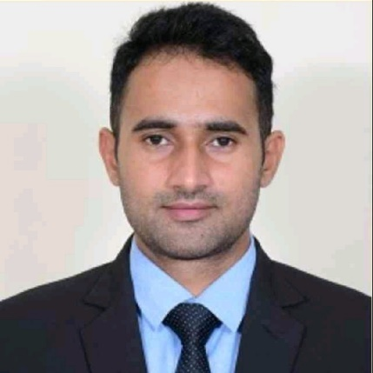
About Me: Hi, I’m Aarav Mehta, a B.Tech Computer Science student at Lovely Professional University, specializing in Full-Stack Development, Artificial Intelligence, and Cloud Computing. I focus on building scalable applications and have a solid foundation in both front-end and back-end development. I am committed to continuously improving my skills in emerging technologies.
📞 Contact Me: +91 98765 43210
📧 Email: aarav.mehta@example.com
🔗 LinkedIn: linkedin.com/in/aarav-mehta
🐱 GitHub: github.com/aaravmehta
Download my CV
My LinkedIn ID

2. Skills & Technologies

🛠 Skills & Technologies
Programming  Languages | Python (Advanced)  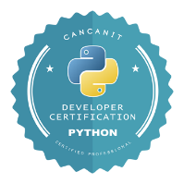 | Java  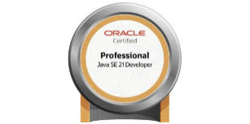 | C++  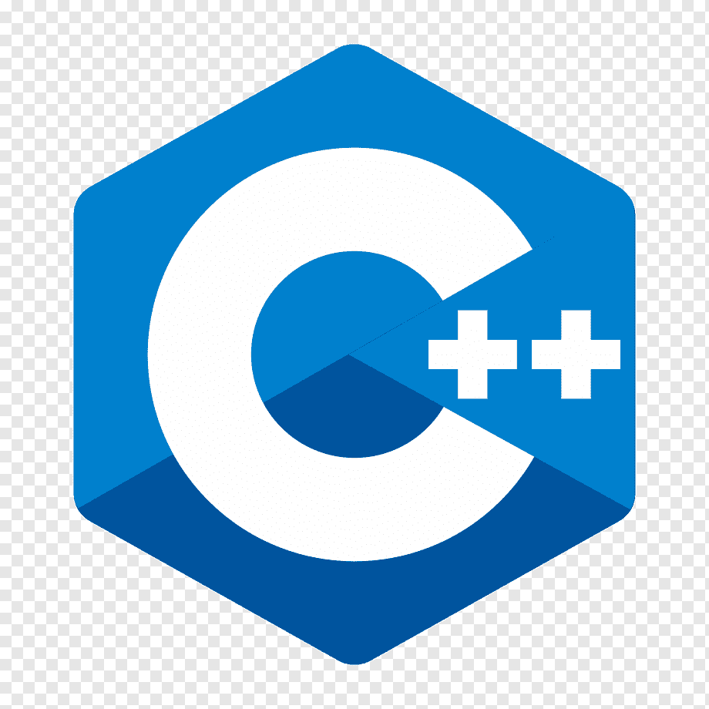 | JavaScript (Advanced)  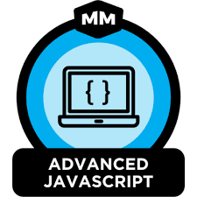
Frontend Development | HTML5 (Advanced)  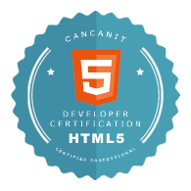 | CSS3 (Advanced)   | Next.js (Intermediate)  
Backend Development | Node.js (Advanced)   | Express.js (Intermediate)  
Databases | MySQL (Intermediate)  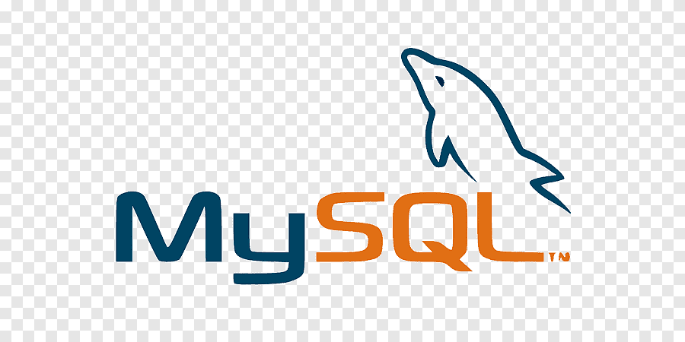
Cloud & DevOps | AWS (Intermediate) | Docker (Intermediate)

3. Projects
Payben - Recharge and Bill Payment Platform  Recharge and bill payment platform based on frameworks like bootstrap for front-end development. MySQL as database, and made use of PHP for backend development. Implemented Android application using MIT App Inventor (provided by Google). Developed APIs to form a smooth interface between database and the platform.  Tech: HTML, CSS, Javascript, Bootstrap, MySQL, PHP, MIT App Inventor | 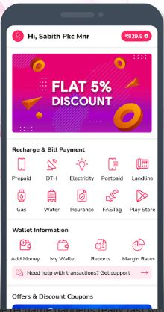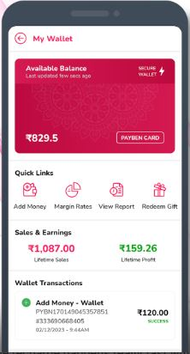
Optmyzr - Shareable Dashboards and White Label:  Shareable Dashboards is a live view of the Account Dashboard contains all the account reports, and can be shared externally as a link with clients or stakeholders. Enabled agency to add their company’s and client’s logo for customization of the dashboard, and setting up a Custom Domain for the dashboard.  Tech: Tableau, SAP, DNS, SSL Certification, CNAME | 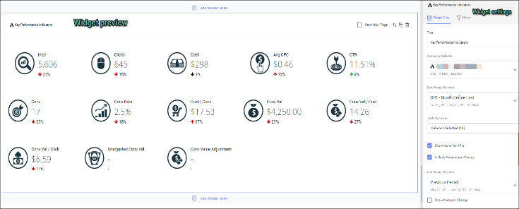  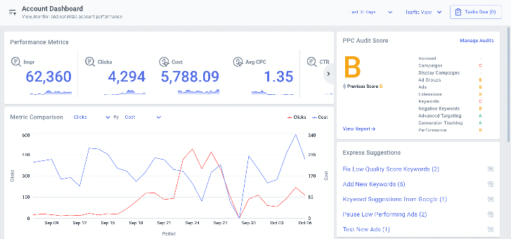

4. Certifications & Courses
Complete Interview Preparation - by GFG  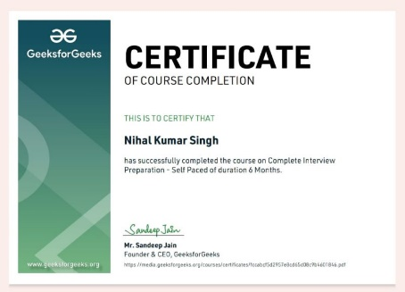 | Development in Flutter- by Programming Pathsala  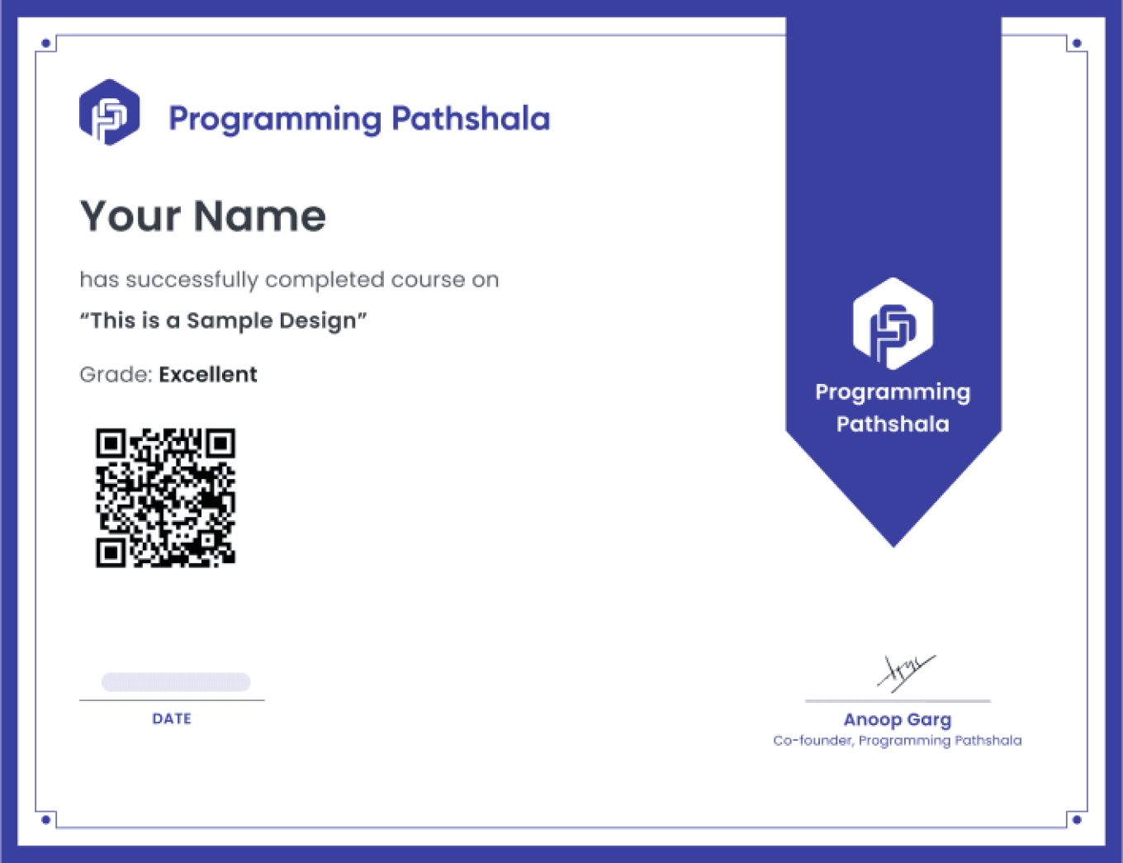 | 100 Days of Code: The Complete Python Pro Bootcamp for 2023- by Udemy  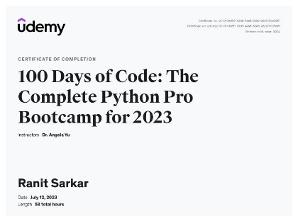

5. Experience (Internships & Work)
Optmyzr - SDE Intern: PPC Management Software Company (Since March 2023)
Roles and Responsibilities:  - Integrated Google Ads and Bing Ads APIs into Optmyzr’s backend infrastructure using .NET. Developed  - Enhanced the user interface of Optmyzr’s web application using React, PHP, and CoffeeScript.  Tech stacks used: Redux , C# · CodeIgniter · .NET Framework · React.js · PHP | 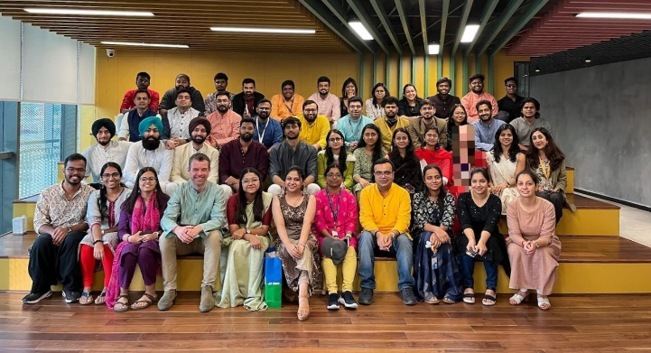

Payben Private Limited- Freelancer (April 2022 - March 2023)

Project Overview:  - Re-developed a recharge and bill payment platform for the startup called Payben.  - Managed recharge services, guaranteed rewards.  - Enabled users to become agents and further offer mobile recharge services.  Tech stacks used: Android and Web platforms | 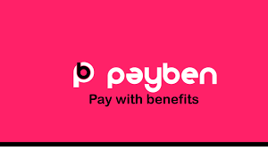

6. Competitions, Hackathons, & Achievements
One among Dean’s top 10 % students at University:  For good academic performance and extra-curricular activities at University.  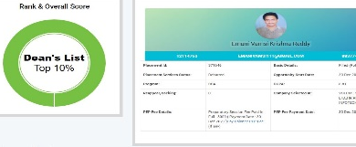 | Secured 3rd rank in the Hackathon: HACKOVERFLOW 5.0: Participated and ranked 3rd in the Hackathon organized by NIT Durgapur.  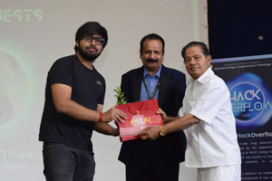 | Received letter of appreciation from Mr. Rajnath Singh (Defence Minister of India): For exceptional performance in AISSCE.  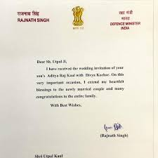

7. Blog & Youtube Channel
Link to my Blog: https://aaravmehta.hashnode.dev/
My Articles:
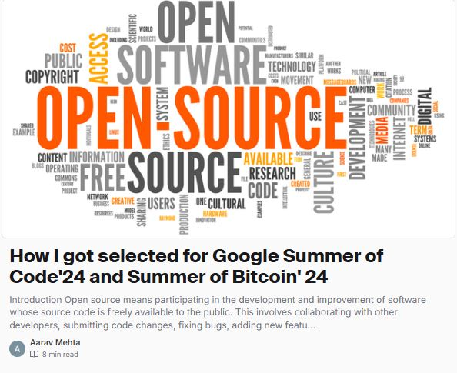 | 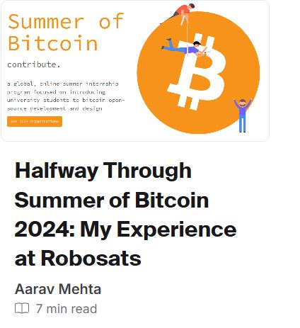 | 

Link to my Youtube Channel: https://www.youtube.com/@lifewidabi

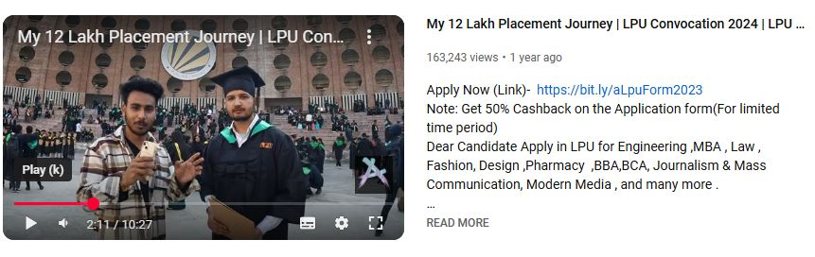

8. Resume
Add a downloadable resume (PDF format).
📂 Example:
📥 Download Resume

